Is Sliding Window approach better for Stock Trend Prediction?

Ankit Thakkar*∗*, Mufaddal Naya

# Abstract

With proper knowledge of any companies stock and insight, one can gain large profit sitting at home. Stock market of a company is a time series data and stock price prediction is one of the field where many researchers had gathered interest to predict the stock prices or trend in future using historical data and technical indicator with high accuracy. Simple Moving Average is very useful in predicting the future price direction and gives a good assumption about the future price. A good prediction model of a stock’s future price will increase trader’s profits. In this report, the proposed model uses deep learning model LSTM — Long short-term memory to predict the stock trend with two different approaches, with and without using a sliding window and comparing their results.

**Index Terms**– Long Short Term Memory**,** Historical Data, Sliding Window Approach, Simple Moving Average, Technical Indicators and Stock Price Prediction.

# Introduction

Stock price prediction is a topic that attracts many data researchers and data analytics as a good stock prediction can capitulate notable profit. Stock of a company cannot just be pre- dicted easily. Stock market is volatile, haywire, uncertain and non-linear data [1]. The stock price of any given company is very much uncertain. Finding patterns in these stocks is a very difficult task. The random change in the stock market is referred as random-walk behavior of stock prices with time by [2]. This statement holds very much true as there are many uncertain factors as if the country’s progress, any natural disaster or the po- litical status of the country.

To predict the stock of some data we need to find some pattern in the stock chart using the raw data or extracting some of the useful Technical In- dicators. Firstly, for prediction of any stock price, we need to analyze the data. For analysis, two ap- proaches are used Fundamental and Technical in-

*∗*Corresponding author.

*Email addresses:* [ankit.thakkar@nirmauni.ac.in](mailto:ankit.thakkar@nirmauni.ac.in) (Ankit Thakkar), [17bit055@nirmauni.ac.in](mailto:17bit055@nirmauni.ac.in) (Mufaddal Naya)

dicators used to forecast stock prices. Fundamen- tal analysis usually deals with the cause of the market, it takes all the macro economic factors such as the company’s growth the climate etc to predict the trend of the future stocks. Technical analysis uses stock charts to analyze the patterns in the stock price. They are derived from the raw data using mathematical formulas. After analyz- ing the data various linear and non-linear models are being used to predict the data like ARIMA (auto regressive model) and ANNs.

# Related Work

Artificial Neural networks like RNN, CNN, and LSTM are commonly used model in stock price prediction [3]. ANN was inspired from function of human brain and implementing a complex net- work of neurons. In [4], they proposed a fusion model implementing HMM, ANN and GA for pre- dicting stock price. These Models are widely used in areas like Image Processing, Natural Language Processing, Time Series Analysis, etc. Over- fitting and under-fitting of data is a big problem while using ANN model for stock price predic- tion [5]. ANNs are very useful for short term fore-

casting. While non-linear model are better choice to predict stocks, many factual researchers had shown that non- linear models might not outper- form linear models every time [6] [7] [8]. Recently in [9], they tried to compare linear model with nonlinear model and tried to find the accuracy, which shows how the nonlinear model outperform linear model. The linear model in the comparison was ARIMA whereas the nonlinear model were GRU and LSTM in which the LSTM outperform every other model. Also in [10], they tried to predict the effect of demonetization on stocks of seven Indian companies CNX, NIFTY50. ANN were used to predict the future values of these stocks. [11] here they used Deep learning mod- els to predict the stock price movement and ana- lyzed the accuracy of many models such as LSTM, CNN, RNN and many other nonlinear models. Also in [12] compared SVM, back propagation and LSTM and analyzed the accuracy.

# Sliding Window

In this work we compared two different ap- proaches for time series forecasting using LSTM, with and without sliding window approach. Slid- ing window approach is predicting F(t+1) con- sidering values from F(t), F(t-1), F(t-2) etc. The similar idea is discussed in [13]. In this work we compared LSTM model with and without Sliding window approach and show how without using any sliding window approach we can get better result compared to model using sliding window approach. We used LSTM to predict the future prices for both the model. LSTM was first pro- posed in [14] by Felix Gers and his adviser Jürgen Schmidhuber and Fred Cummins who introduced the forget gate to deal with the vanishing gradi- ent problem. LSTM is one of the most important model because of the introduction of forget gate and memory cell. In this model, the information flows through a mechanism known as cell states. Due to these memory cells now, LSTM selects and remember or forget things according to its impor- tance. Therefore, LSTM can learn and identify patterns of data dynamically with time and pro- duces huge prediction accuracy. FA GersD, EckJ

and Schmidhuber first used LSTM for time se- ries forecasting long back in 2002 in [15]. Sliding window approach using LSTM is frequently used as in [16], they compared LSTM, RNN and CNN using sliding window approach.

# Methodology

For Prediction of Stock Market, we need to deal with huge historical data that is highly nonlinear. To deal with this high non-linearity we need to find hidden pattern in our data and analyze them for prediction of future prices. Yet pattern identi- fication given a nonlinear data is a trivial task and therefore there is a need of a dynamic model that could analyze our data and find all the hidden pat- terns. ANNs are very useful and capable of find- ing all the hidden patterns and exploiting the data to predict the future prices through self-learning process. These Neural networks are very efficient to predict the stock future prices and therefore are widely used. To predict a financial time se- ries data Using Neural networks was introduced in [17]. In this report, we have used Long Short Term Memory as a prediction model to predict the stock price of Netflix using Historical data of past 17 years from https://finance.yahoo.com/.

In this report we have divided the prediction approach into subtopics and the subtopics are as follows:

* 1. *Data Gathering*

In this work, 17 years of data of Netflix from March 2002 to March 2019 is used. All the data has been collected from https://finance.yahoo.c om/ and downloaded under the historical data section. This Historical data is used to predict the future stock prices using LSTM Architecture.

* 1. *Data Processing*

Before we train the LSTM model, we need to process the data. Processing is done by extract- ing some of the features from the stock price and normalizing the data.

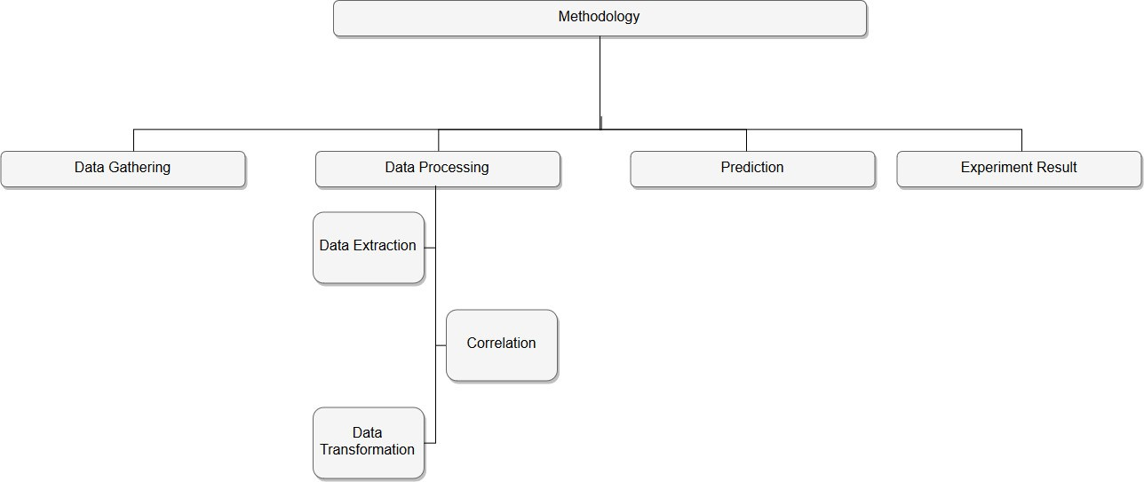

Figure 1: Structure of this paper

* + 1. *Feature Extraction*

The historical data gathered was raw unpro- cessed data with high volatility. Prediction us- ing this raw data is not a good option so first we need to process this data. Therefore, we have cal- culated technical indicators. Technical Indicators are the detailed study of past Market action for the purpose of forecasting future prices. It helps in forecasting the price direction and the current trend.

Some of the technical indicators which we used in this work are listed in Table 1

* + 1. *Correlation*

After extracting all these features we cannot use all these features in our model as not all features are relevant some of them are irrelevant and in- troduces noise in our model. Also, having redun- dant features confuses our model and therefore increases the computational time. Therefore, we only need to select those features that are related to our stock price, and we could discard other fea- tures.

The selection of features was based on the cor- relation coefficient value of all these features with the original stock’s closing prices. The features with the highest correlation value was selected. The correlation techniques used over here where

Table 1: Technical Indicators

Technical Indicators

Simple Moving Average - SMA Exponential Moving Average - EMA

Triple Exponential Moving Average - TEMA Kaufman’s Adaptive Moving Average - KAMA Moving Average Convergence/Divergence

-MACD

Bollinger Bands

%B

Relative Strength Index - RSI Average True Range - ATR Chandelier Exit - CE

Chande Momentum Oscillator - CMO Force Index - FI

Elder-ray Stochastic %k Stochastic %D Williams %R

Accumulation Distribution Oscillation - ADO Commodity Channel Index - CCI

Scatter diagram and Pearson Correlation value.

*Scatter Diagram.* After extracting all these fea- tures we cannot use all these features in our model the as not all features are relevant some of them are irrelevant and introduces noise in our model. Also, having redundant features confuses our model and therefore increases the computa- tional time. Therefore, we only need to select those features that are related to our stock price, and we could discard other features.

The selection of features was based on the cor- relation coefficient value of all these features with the original stock’s closing prices. The features with the highest correlation value was selected. The correlation techniques used over here where Scatter diagram and Pearson Correlation value.

The scatter diagram for SMA and closing price of the data is shown inFigure 2

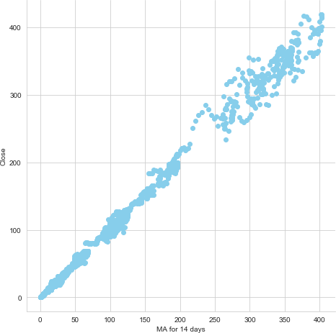

Figure 2: Scatter Diagram for SMA for 14 days vs Close

*Pearson Correlation.* Pearson Correlation gives a numerical response for finding the relation be- tween different data set. It assigns a number to the extent of relation between two data sets. Its value lies from -1 to 1, 1 representing exactly lin-

ear relation between two data sets and 0 repre- senting no relation.

The formula for calculating Pearson correlation coefficient is Equation (1)

.ΣΣ *− −*

((*x x*)(*y y*))

*r* =

Σ

(*x − x*)2 (*y − y*)2 (1)

After analysis the Data using Pearson correlation and verifying using scatter diagram Simple mov- ing average for 14 days was chosen as the param- eter for the input for stock prediction for Netflix. A SMA for 14 days of closing price of a stock is defined as the rolling average of closing price of the stocks over the last 14 days. A SMA helps in smoothing out the curve which helps in reducing the volatility in the curve. SMA is used for pre- dicting the trend of the direction of price in the future.

* + 1. *Data Transformation*

After getting the best feature, the next thing we do is data transformation. Data transforma- tion is used to normalize the data and make the data stationary, which helps in pattern finding. Normalization helps improve convergence of the data. The data was transformed/mapped in the range 0 to 1.

After the data set is transformed into a clean data set, the data set is divided into training and testing sets to evaluate the prediction accuracy of my model. The training set is 95 percent of the total data set and the testing data is the rest of the data.

# Prediction Models

In this work, we have implemented LSTM ar- chitecture and compared two different approaches with and without sliding window to understand which one performs better. LSTM was introduced to have long termed dependencies and deal with the vanishing gradient problem.

* 1. *LSTM without Sliding Window Approach*

The model was trained for 40 epochs and a batch size of 60. 60 days sliding window approach

was used to predict the future trend. Initially the number of epochs were 100 and changed ac- cordingly to build a good prediction model. This LSTM model was initialized of an input sequential layer lead by 4 LSTM layers each having neurons lesser than the previous and then finally a dense output layer with Adam optimizer and loss mean square error.

* 1. *LSTM without Sliding Window Approach*

The input to this architecture is moving aver- age of previous day and predicting the next day moving average. The Architecture of this LSTM model is same as the previous one with 40 epochs and a batch size of 60. Also, the network consist of one input layer with any sliding window This LSTM model was initialized of an input sequential layer lead by 4 LSTM layers each having neurons lesser than the previous and then finally a dense output layer with Adam optimizer and loss mean square error.

# Experimental Result

Root Mean Square Error (RMSE) is used to calculate the error for each model. The parameter setting for both the models is given in Table 2.

Table 2: Parameter setting for both the Models

Parameter Value

Input SMA 14

Hidden Layer 4

Optimizer Adam

Loss Function mean square error

Epoch 40

Batch Size 60

* 1. *LSTM with Sliding window*

The result for training and testing data is shown in Figure 3Figure 4 respectively. The RMSE for training and testing data is shown in Table 3.

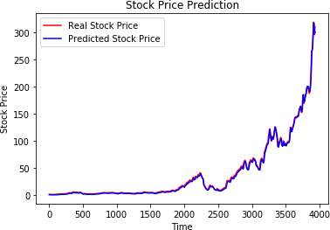

Figure 3: Result of LSTM with sliding window model for Train data set

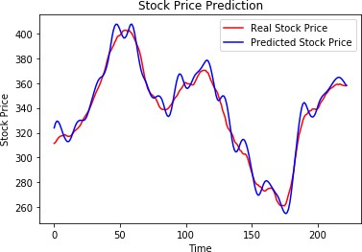

Figure 4: Result of LSTM with sliding window model for Test data set

Table 3: Result for LSTM with Sliding window model

Input RMSE Size

Train 2.5983 3934

Test 6.3923 223

* 1. *LSTM without Sliding window*

The result for training and testing data is shown in Figure 5Figure 6 respectively. The RMSE for training and testing data is shown in Table 4.

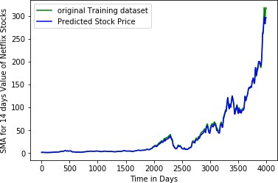

Figure 5: Result of LSTM without sliding window model for Train data set

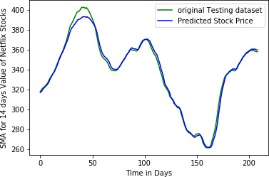

Figure 6: Result of LSTM without sliding window model for Test data set

Table 4: Result for LSTM without Sliding window model

Input RMSE Size

|  |  |  |
| --- | --- | --- |
| Train | 2.8778 | 3994 |
| Test | 3.5498 | 211 |

# Conclusions

In this work, we tried to compare two differ- ent approaches to understand which performs bet- ter. We predicted trend of stocks of Netflix using Sliding window and without using sliding window and from the results it was clear that without us- ing a sliding window gives better result compared to with using sliding window. SMA for 14 days was used as an input parameter for both the ap- proaches. We would like to highlight forecasting stock prices or trend are very much helpful for in- vestors to earn huge profit. Different methods are adopted to predict the future price. Predicting future price or trend of a given stock to produce an accurate result is encouraging researchers to find some new technique to improve the accuracy. RNNs like LSTM are very good at processing se- quential time series data. LSTM has been proven a very good solution while dealing with sequential data streams. In this work, we were able to pro- duce significantly good result without using slid- ing window approach and LSTM architecture to predict the future trend of Netflix stocks by pre- dicting the SMA for the stock.

# References

1. K. C. Brown, W. V. Harlow, S. M. Tinic, Risk aver- sion, uncertain information, and market efficiency, Journal of Financial Economics 22 (2) (1988) 355– 385.
2. B. G. Malkiel, E. F. Fama, Efficient capital markets: A review of theory and empirical work, {The journal of Finance} 25 (2) (1970) 383–417.
3. O. Coupelon, Neural network modeling for stock movement prediction A state of the art, {Blaise Pas- cal University} (2007) 83.
4. M. R. Hassan, B. Nath, M. Kirley, A fusion model of HMM, ANN and GA for stock market forecast- ing, {Expert systems with Applications} 33 (1) (2007) 171–180.
5. X. Tao, H. Renmu, W. Peng, X. Dongjie, Input di- mension reduction for load forecasting based on sup- port vector machines, in: {2004 IEEE International Conference on Electric Utility Deregulation, Restruc- turing and Power Technologies. Proceedings}, Vol. 2, 2004, pp. 510–514.
6. A. A. Adebiyi, A. O. Adewumi, C. K. Ayo, Compari- son of ARIMA and artificial neural networks models for stock price prediction, {Journal of Applied Math- ematics} 2014.
7. C. K. Lee, Y. Sehwan, J. Jongdae, Neural network model versus SARIMA model in forecasting Korean stock price index (KOSPI), {Issues in Information System} 8 (2) (2007) 372–378.
8. K. J. Lee, A. Y. Chi, S. Yoo, J. J. Jin, Forecasting korean stock price index (kospi) using back propa- gation neural network model, bayesian chiao’s model, and sarima model, {Journal of Management Informa- tion and Decision Sciences} 11 (2).
9. X. Zhang, C. Li, Y. Morimoto, A Multi-factor Ap- proach for Stock Price Prediction by using Recurrent Neural Networks, {Bulletin of Networking, Comput- ing, Systems, and Software} 8 (1) (2019) 9–13.
10. S. Chopra, D. Yadav, A. N. Chopra, Artificial Neural Networks Based Indian Stock Market Price Predic- tion: Before and After Demonetization, {J Swarm Intel Evol Comput} 8 (174) (2019) 2.
11. W. Long, Z. Lu, L. Cui, Deep learning-based fea- ture engineering for stock price movement prediction,

{Knowledge-Based Systems} 164 (2019) 163–173.

1. N. Arora, et al., Financial Analysis: Stock Market Prediction Using Deep Learning Algorithms.
2. E. Zivot, J. Wang, Rolling analysis of time series (2003).
3. F. A. Gers, J. Schmidhuber, F. Cummins, Learning to forget: Continual prediction with LSTM.
4. F. A. Gers, D. Eck, J. Schmidhuber, Applying LSTM to time series predictable through time-window ap- proaches (2002).
5. S. Selvin, R. Vinayakumar, E. A. Gopalakrishnan,

V. K. Menon, K. P. Soman, Stock price prediction us- ing LSTM, RNN and CNN-sliding window model, in: 2017 International Conference on Advances in Com- puting, Communications and Informatics (ICACCI), 2017, pp. 1643–1647.

1. H. White, Economic prediction using neural net- works: The case of IBM daily stock returns.